FS40 Pivot Bracket

Version 2.0

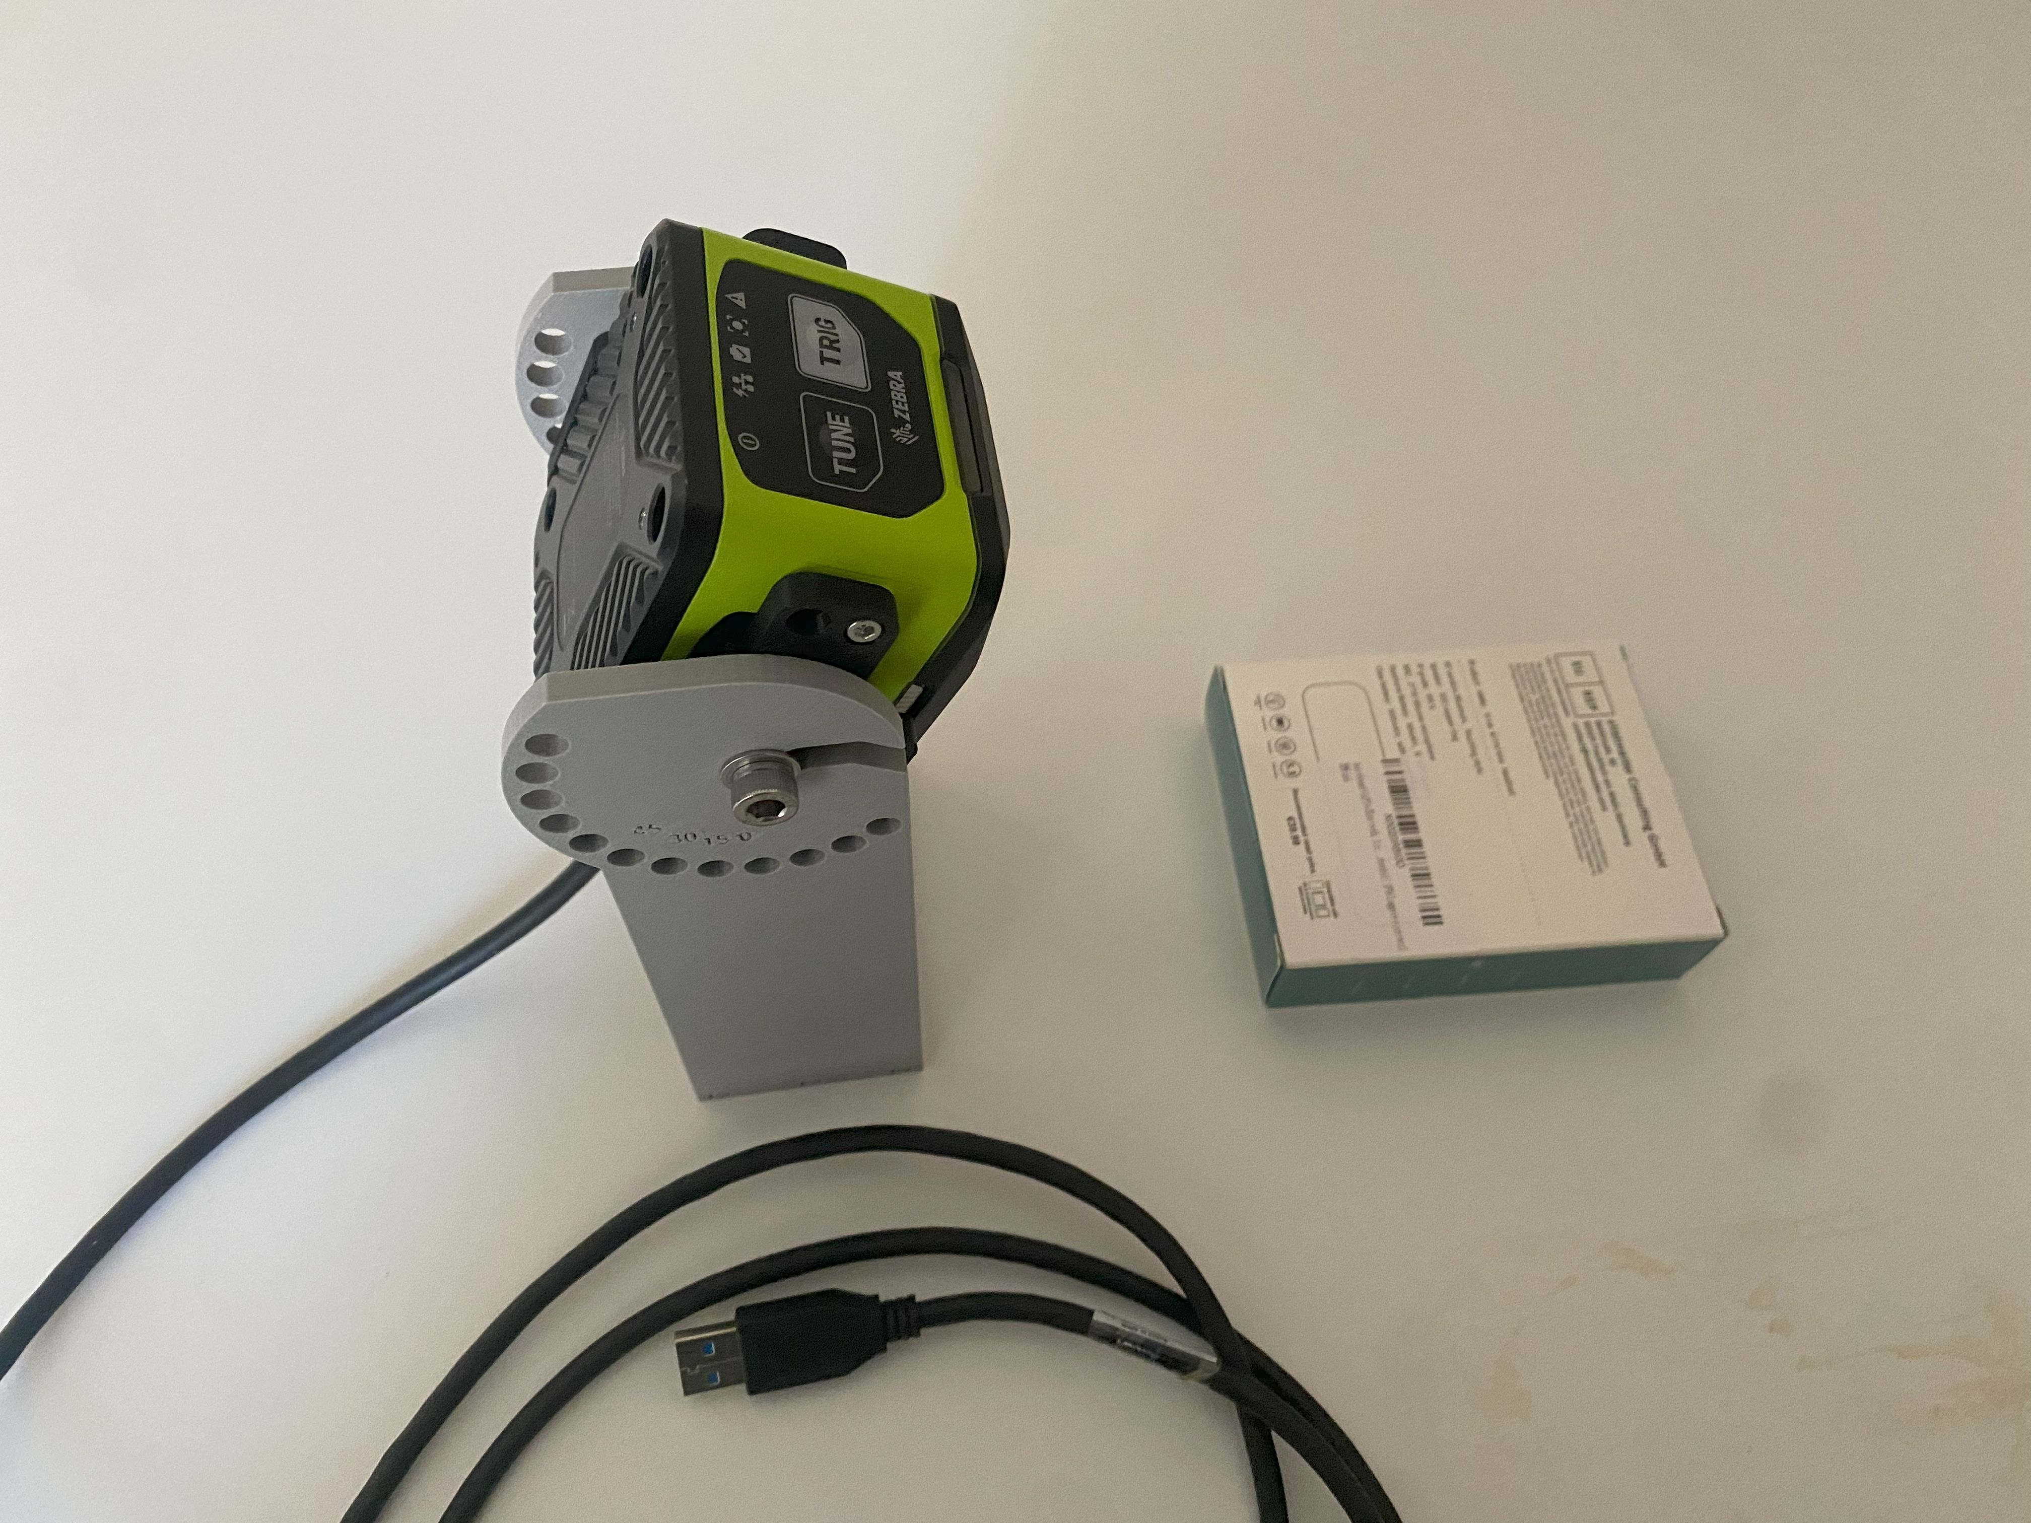

Version 2.0
- Rotation angle expanded
- Fixed an issue with the text on one side (but the resulting text has a poor quality)
- Larger 8.2 hole in the base

Camera drawings
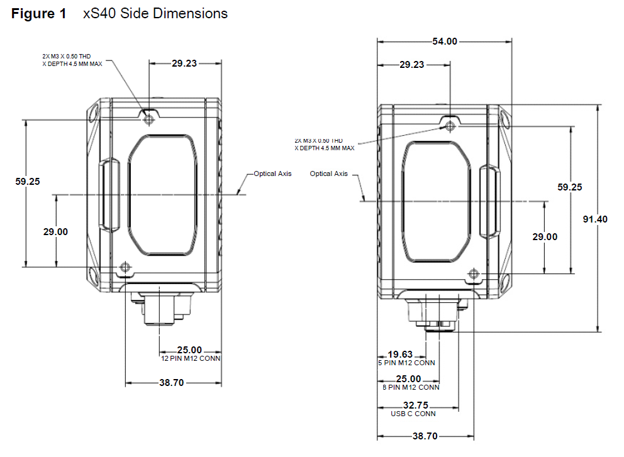

Adapter Plate
This plate is to connect to the camera side to the bracket creating a hinge centered around the camera optical axis
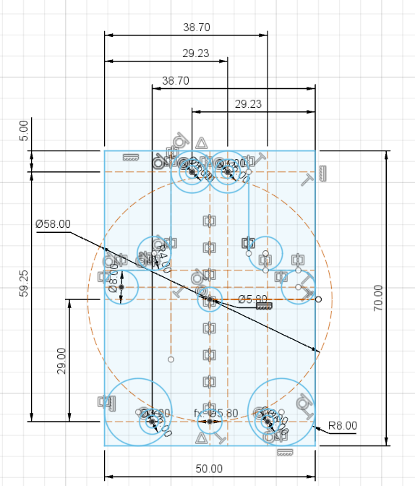

The bracket is symmetric and has twice the needed M3 holes just to use the same plate on both sides.
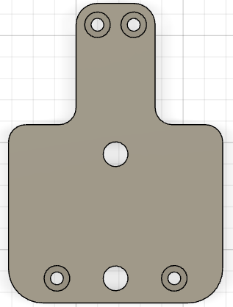 | 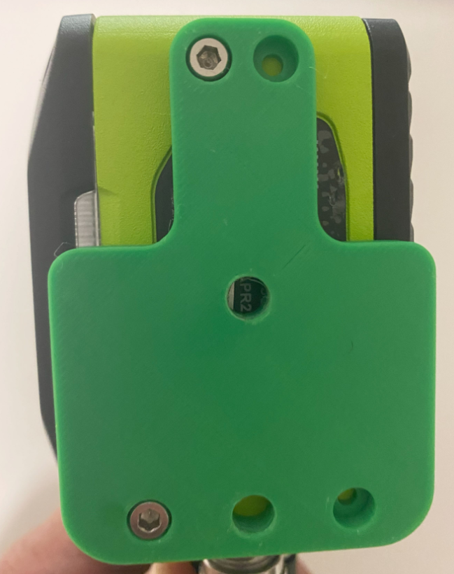

Base
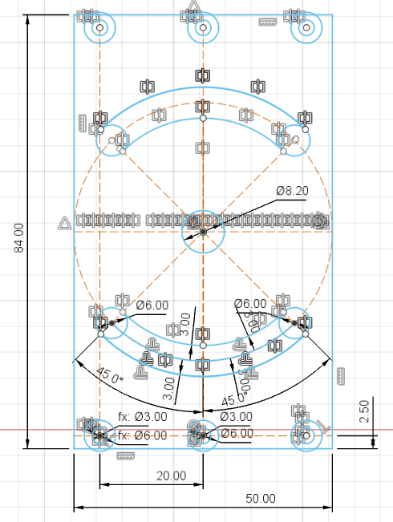

Final result
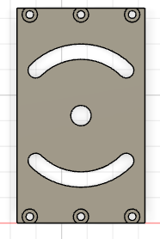

Shoulder
Version 2.0: larger rotation angle thanks to more locking holes. Now we can rotate from -45° to 120°

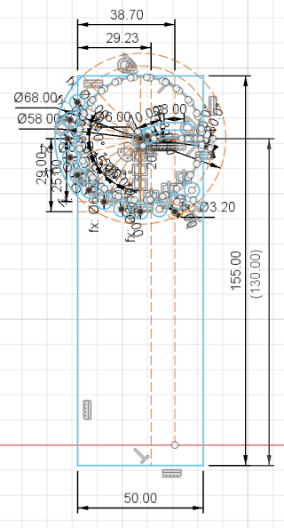

This is the detail about the locking holes
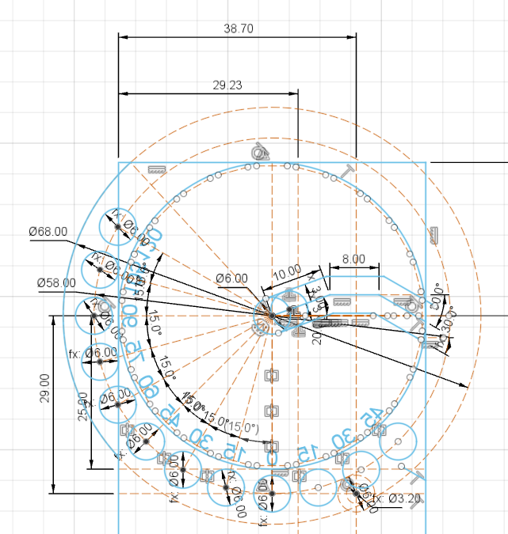

The pivot is made with 2 angles so the camera wouldn't fall down even with the brackets in vertical position. Two small teeth act as a stop block.
 | 

Embossed text indicate the rotation angle (but the result is not satisfactory)
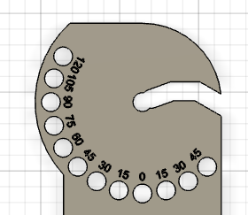 | 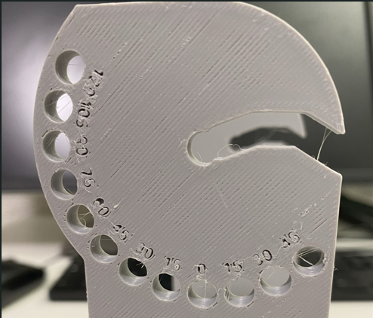
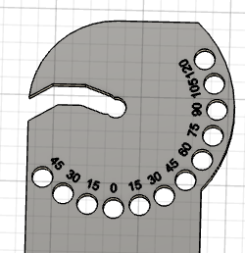 | 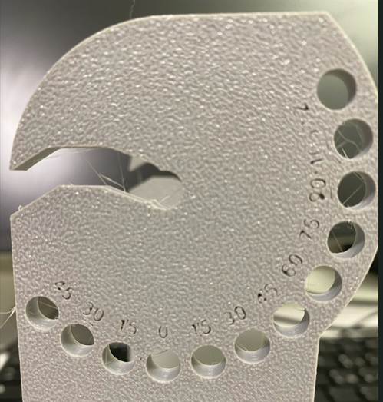

BOM
- M3 x 20 Screws: 6
- M3 x 10 Screws: 4
- M6 x 10 Screws: 4
- 6mm washers: 2
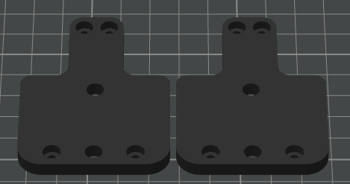

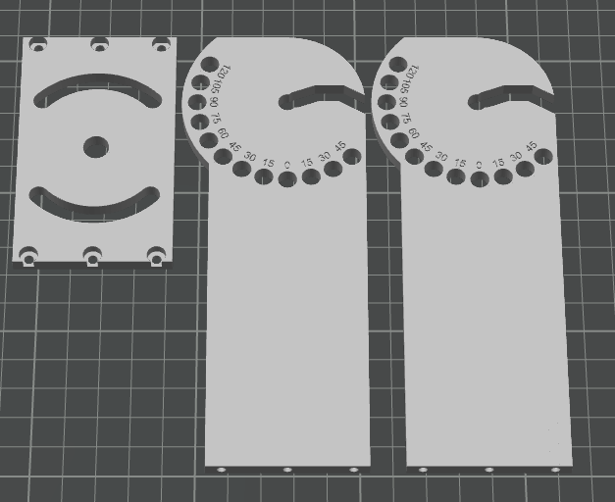

Final result

For the next iteration
Change the adapter shape to make the 360 Feedback LED visible | 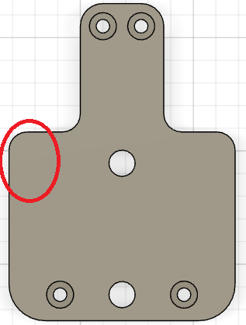
Rethink the central part of the adapter to make the label visible | 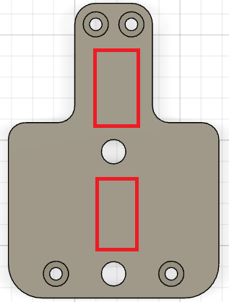
Reduce the size to align with the camera body | 